Warrenpoint Harbour Authority
Notice to Mariners
No. 6 of 2022

infinity Channel Swim - Hit the Wall Event
To: Ship Owners, Operators, Managers, Masters, Pilots, Agents, Stevedores, Fishermen and Yachtsmen.
Warrenpoint Harbour Authority hereby gives notice of the following:

A number of swimming events are scheduled to take place in Carlingford Lough from Friday the 27th of May to the 30th. Mariners are reminded to navigate with particular caution when operating in or near these areas taking particular regard to passing speeds and wave wash.

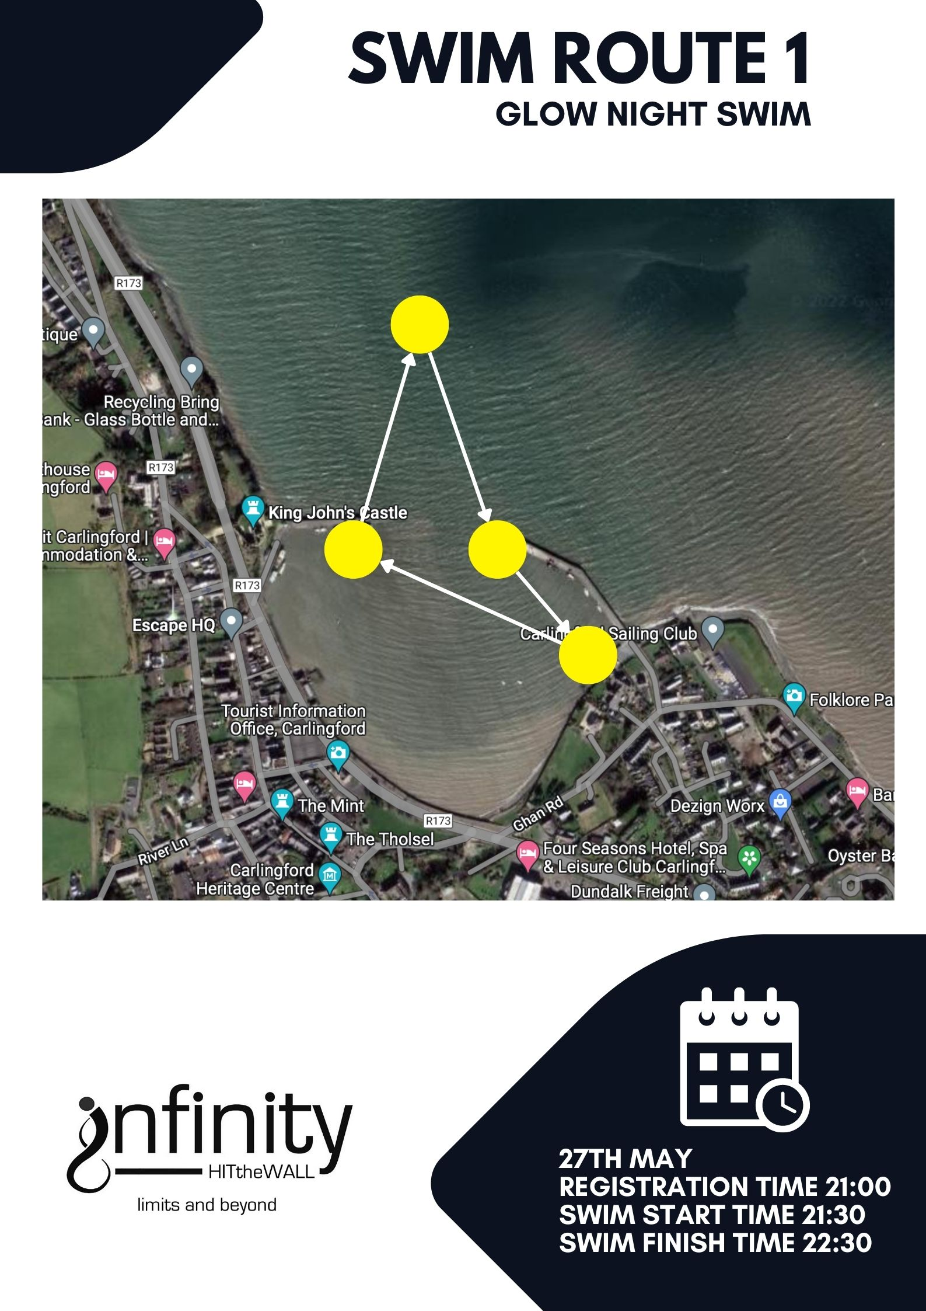

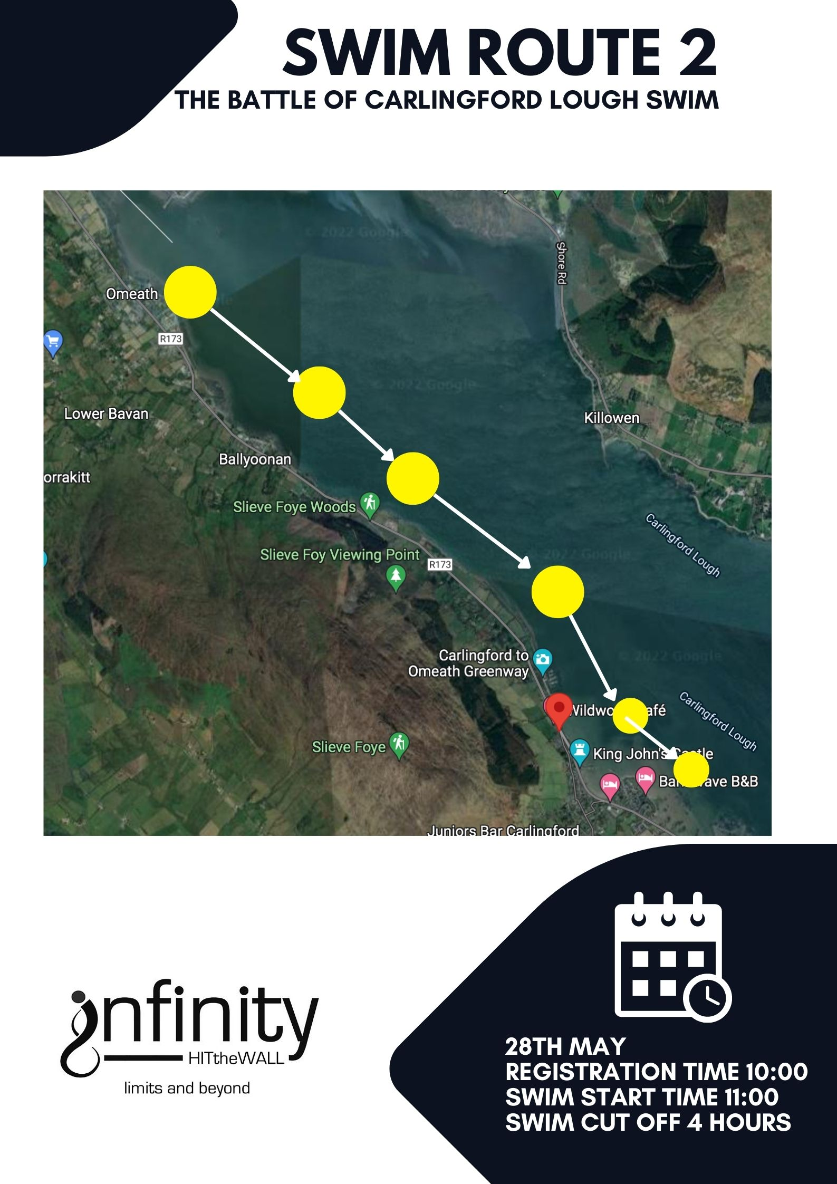

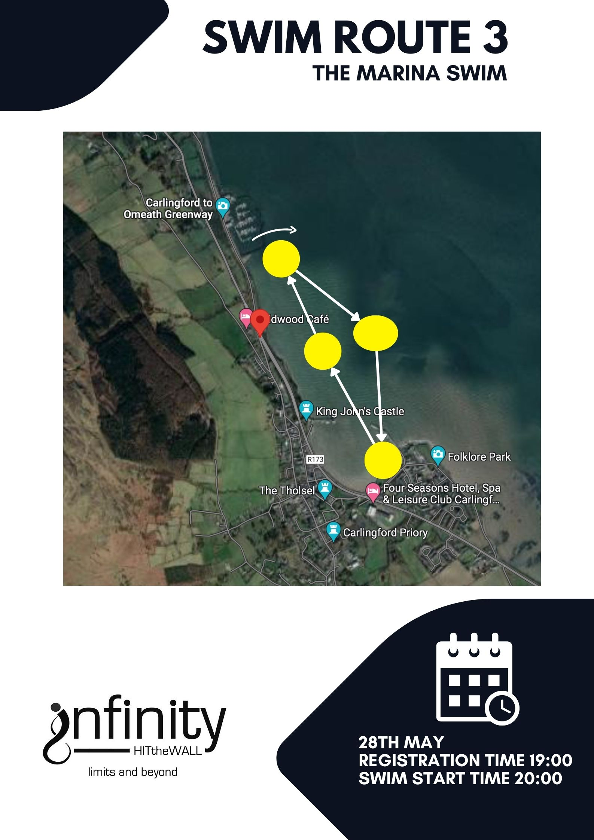

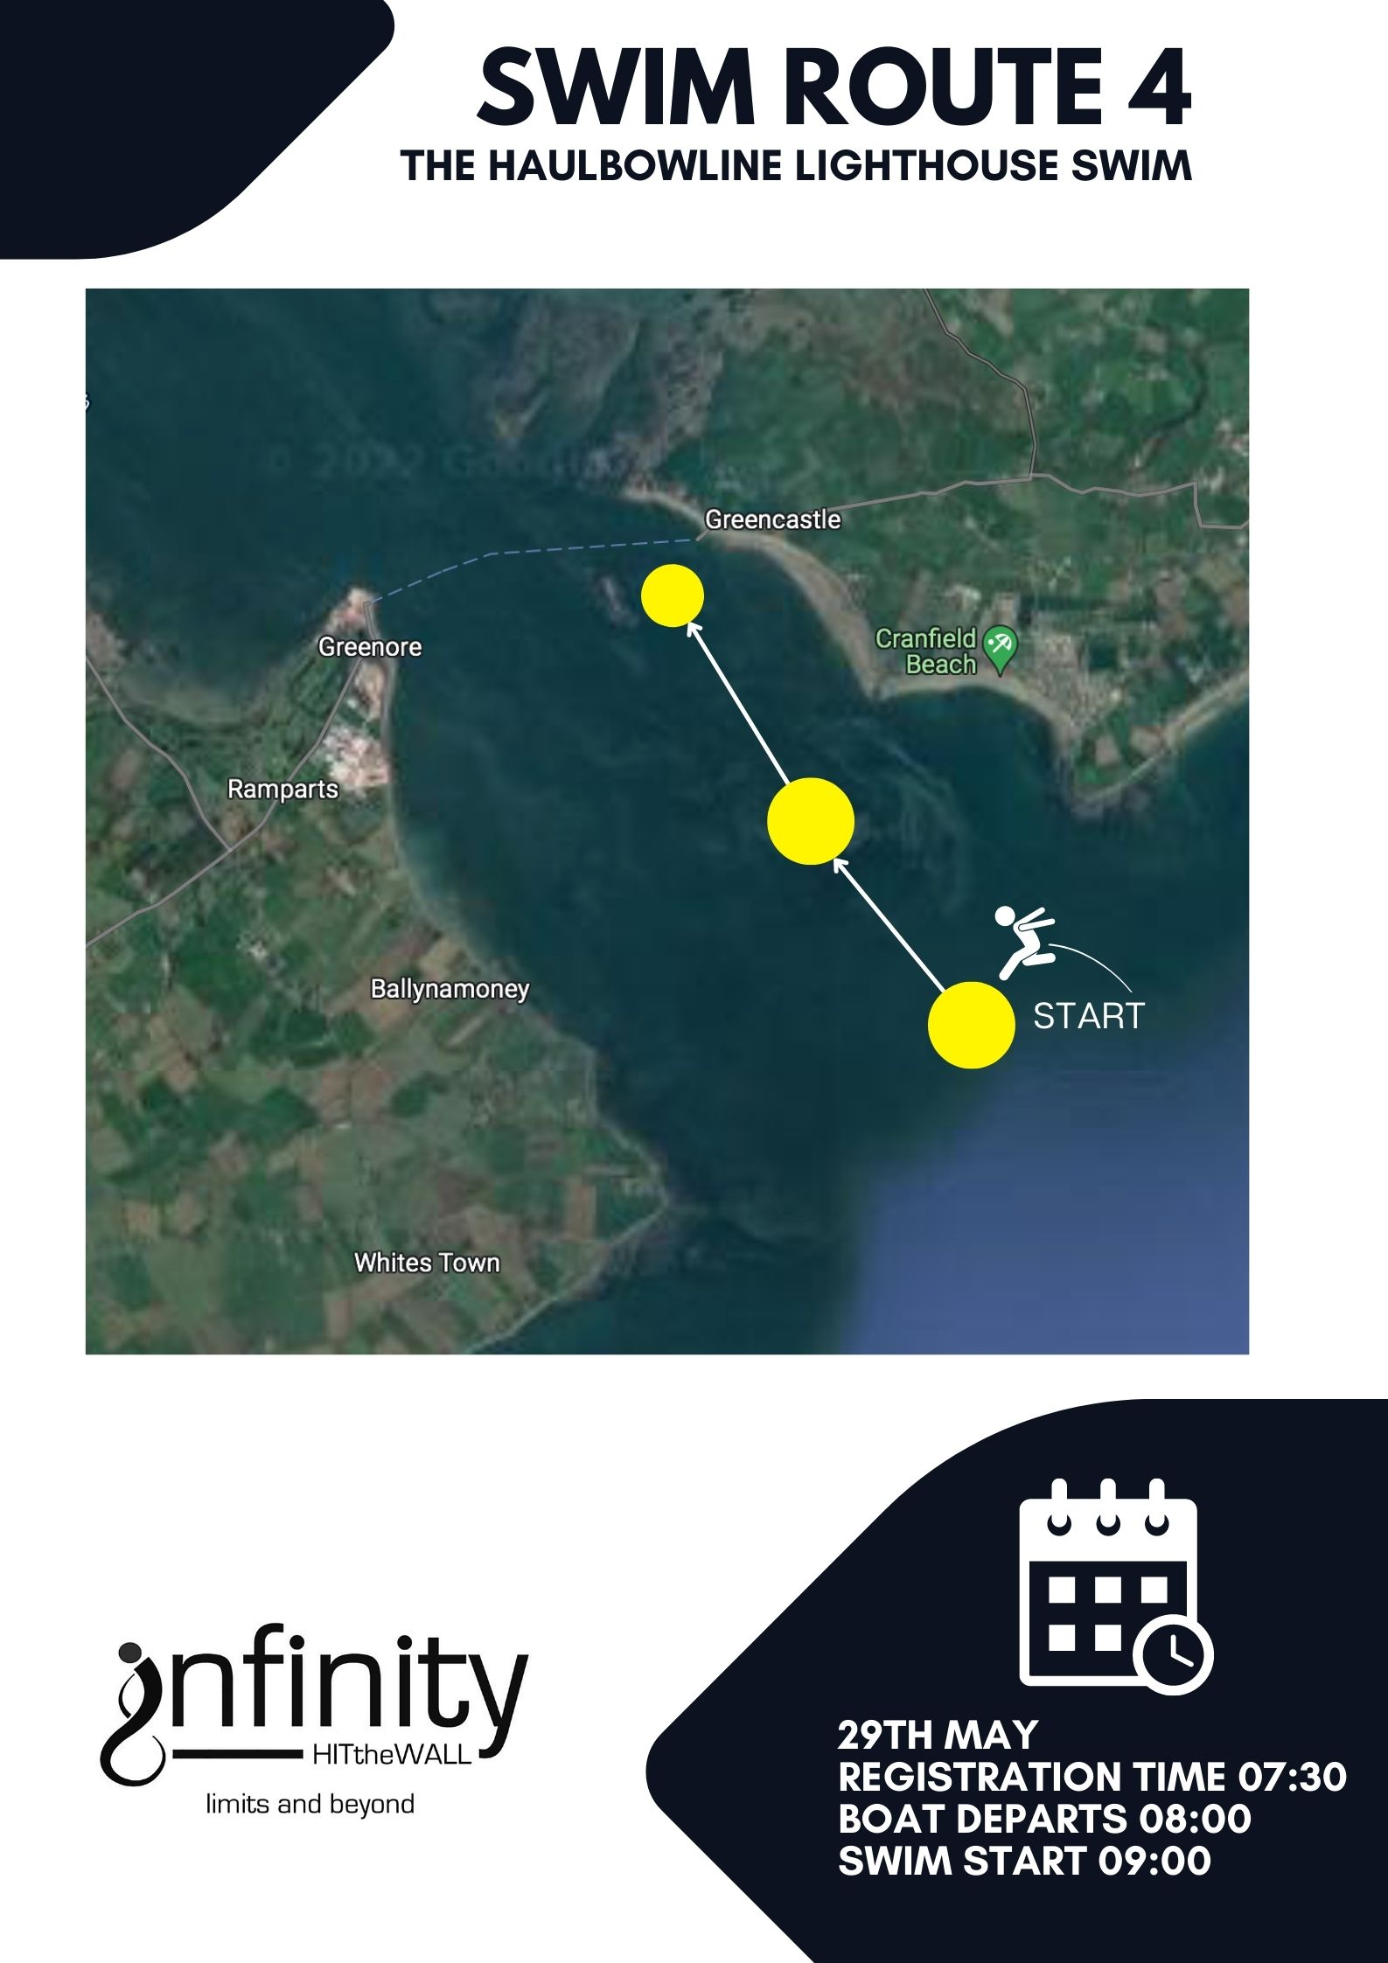
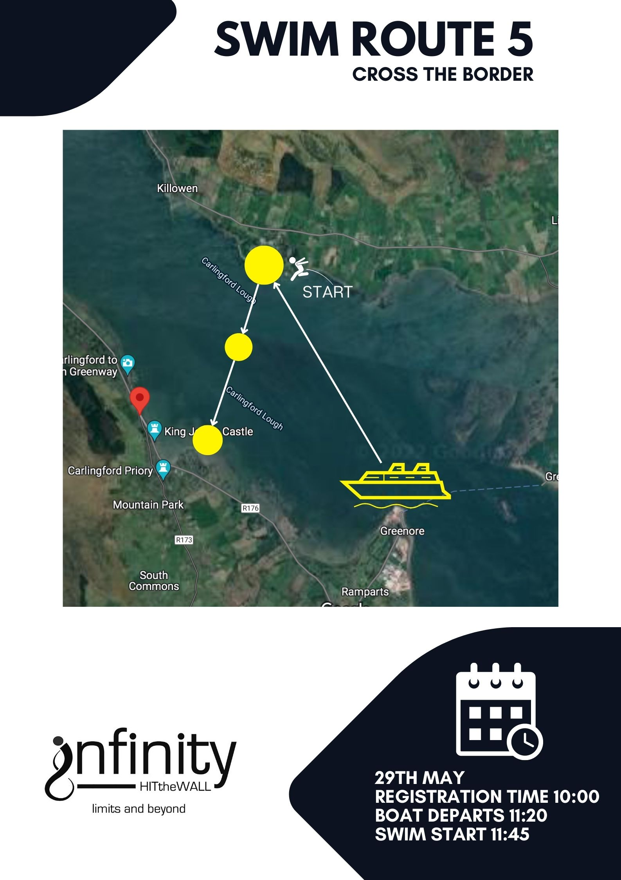
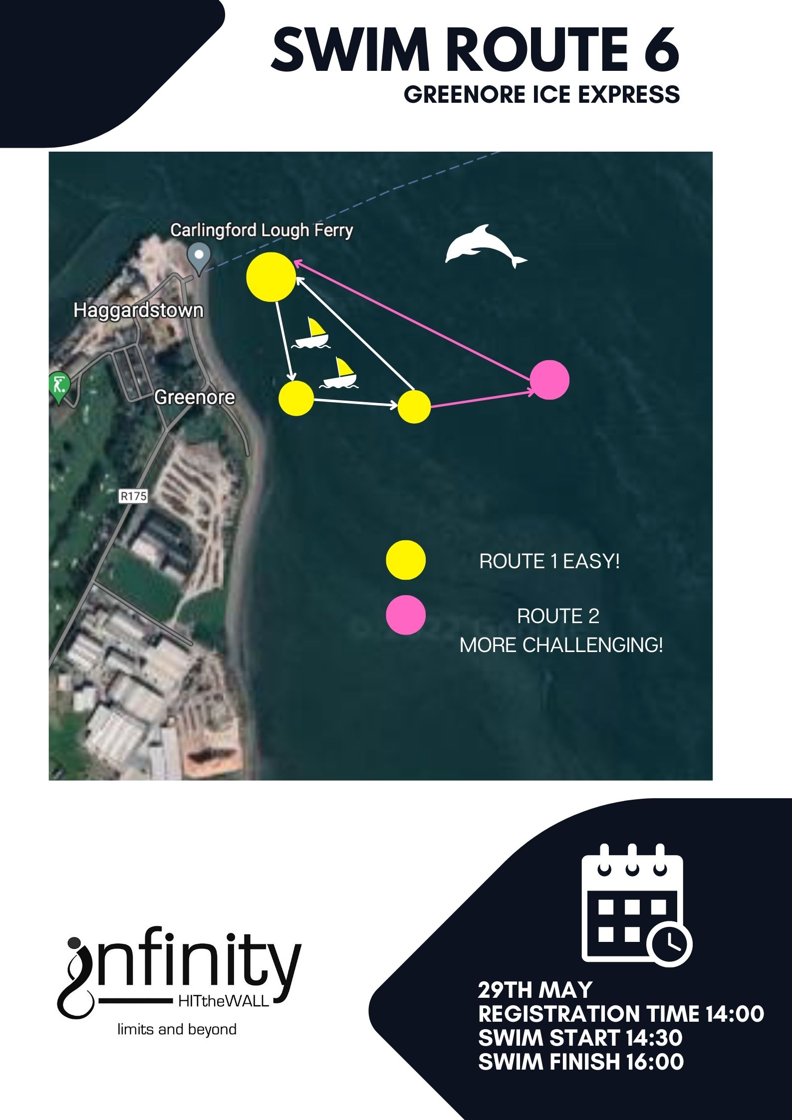

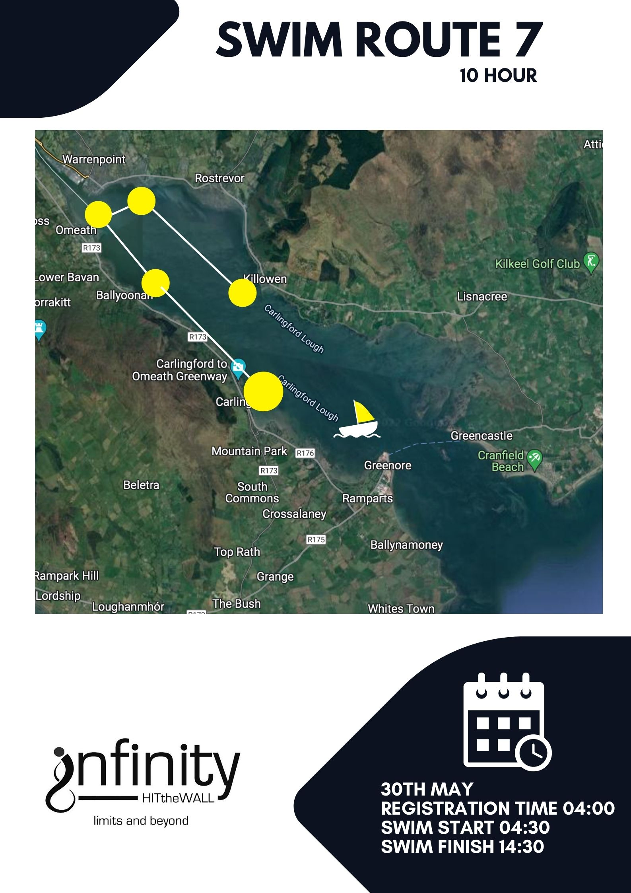
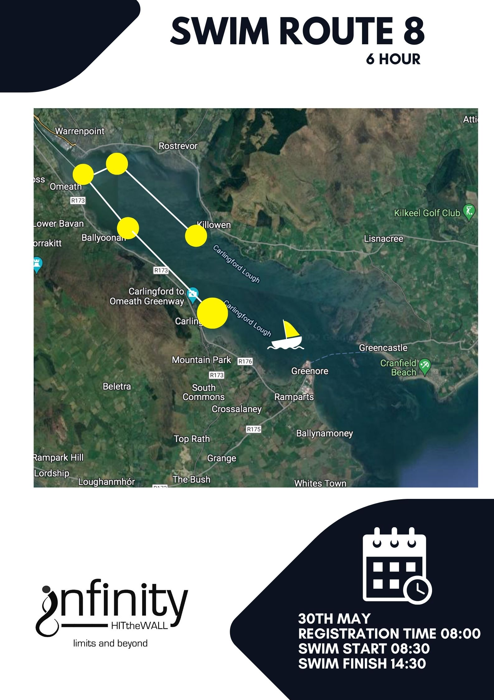

There will be up to 5 rescue boats and 12 of Sea kayakers on the water during these events.
Each boat will have a pilot and a beach life guard.

Additional assistance available from the shore.
A land-based team will be on duty for return of any swimmers before the swim end time. They will have VHF radio contact with all boats and as specified in the EAP will give advanced notice if a swimmer is to be taken to shore. The swimmer’s number will be relayed to the onshore team so as to ensure collation of total in - out numbers.

Boarding and transfer of injured or vulnerable persons to/from craft
Swimmers will board the craft from the water via a ladder or a roll up recovery method.

Minimum qualifications of those crewing rescue boats: Day Skipper
Beach lifeguard

Minimum safety equipment carried on each rescue boat
First aid kit, blankets; hot juice, rescue aid.

Communications procedures and plans with rescue boats:
Notification to harbour master at start and end of swim.
Regular communication via VHF to onshore team and between boats

The follow up operation once a casualty is ashore, first aid and subsequent actions should the event occur:

Once onshore the swimmer will be assessed by the medic present and decisions made regarding follow up first aid assistance or the requirement of further medical assistance. Tight control and monitoring of the swimmers during the swim will be standard and swimmers will be regularly checked for signs of hypothermia.

Director need to summon additional assistance from exterior emergency services.
Medic on duty will make the decision to call for emergency assistance and this will be communicated to race director Catherine Murphy.

Contact Details
Event Organisers:
infinity Channel Swimming
101 CAMLOUGH ROAD,
NEWRY
BT35 7EE
Race Director:
Pádraig Mallon Jacqueline McClelland
07879413131 07730308958

Issued by Warrenpoiont harbour Authority)
Warrenpoint Harbour Authority
Issued 25th May 2022

This Notice is Self-Cancelling

